Project Design Phase-II
Data Flow Diagram & User Stories
Date | 31 January 2026
Team ID | SWTID-2026-1597
Project Name | AI Fit Track API – Personalized Fitness Tracking with AI-Powered Insights
Maximum Marks | 4 Marks

Data Flow Diagrams:
The DFDs show how data enters the AI Fit Track API, how it is processed by the authentication, workout, goal, statistics and AI insight processes, and where it is stored in MongoDB.
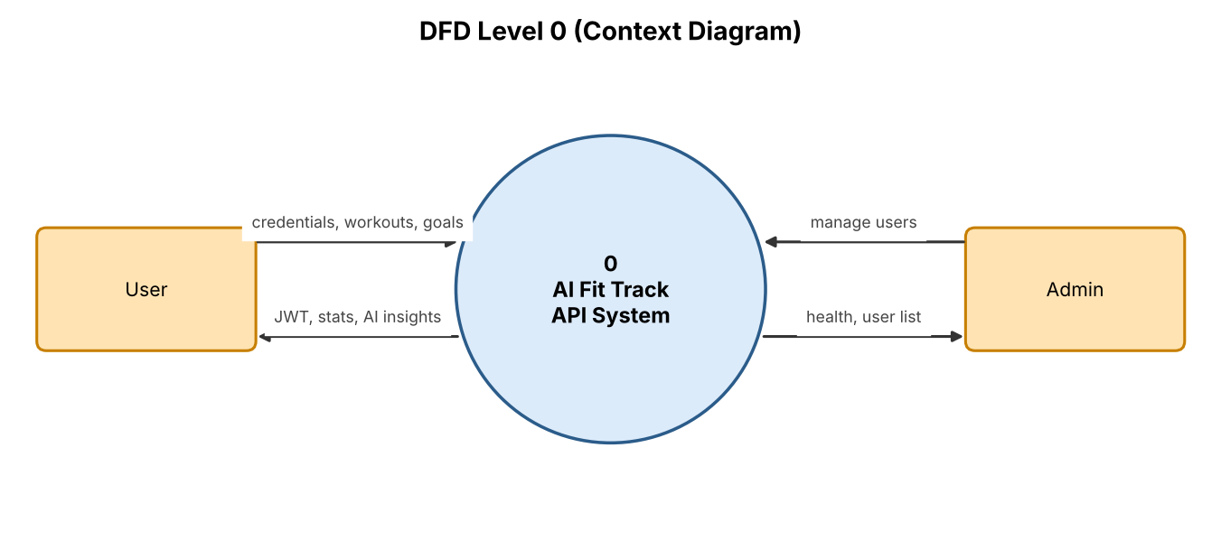
Figure 1: DFD Level 0 – Context diagram
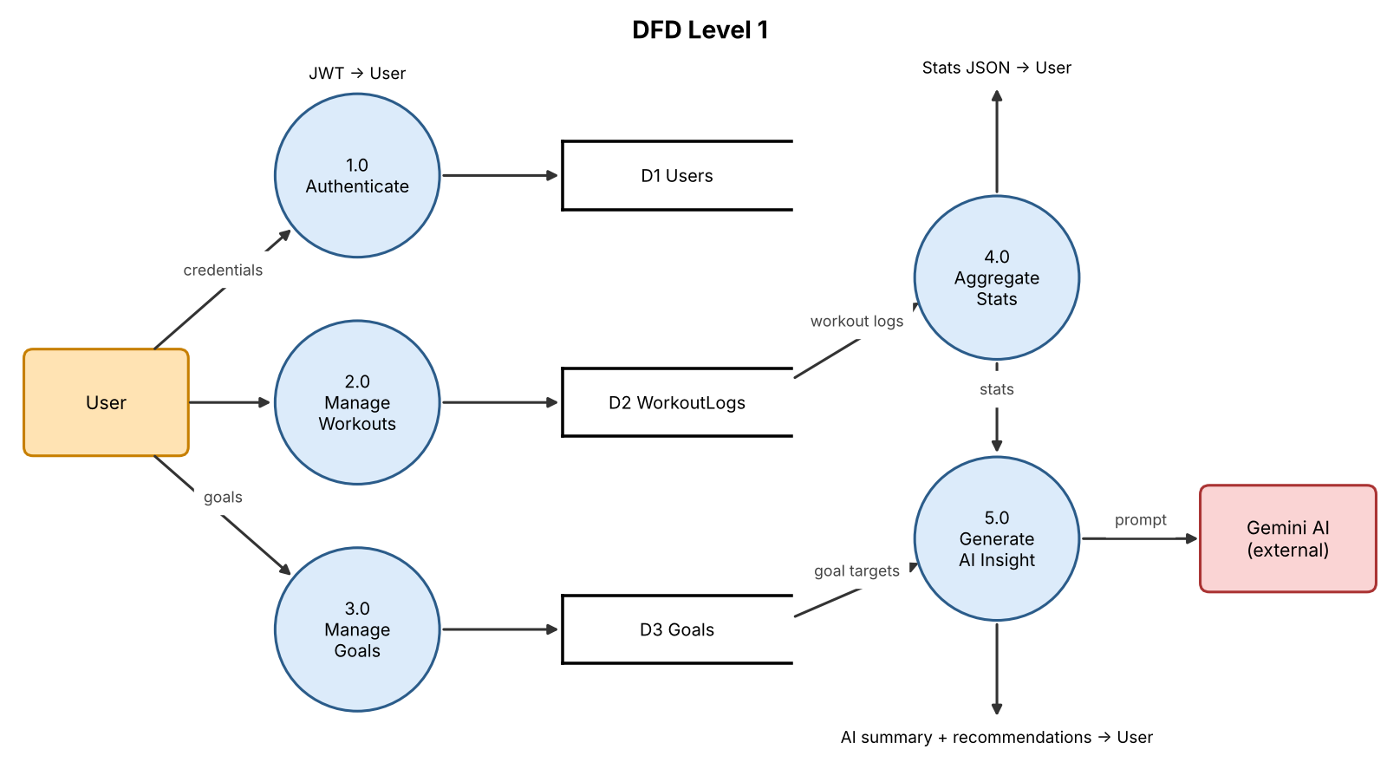
Figure 2: DFD Level 1 – Main processes and data stores
User Stories
User Type | Functional Requirement (Epic) | User Story Number | User Story / Task | Acceptance criteria | Priority | Release
Registered User | Registration | USN-1 | As a user, I can register by entering my name, email and password. | Account created with hashed password; 201 response | High | Sprint-1
 | Registration | USN-2 | As a user, I cannot register with an email that already exists. | Duplicate email rejected with a clear error | High | Sprint-1
 | Login | USN-3 | As a user, I can log in with my email and password and receive a JWT token. | Valid credentials return JWT; invalid return 401 | High | Sprint-1
 | Workout Log | USN-4 | As a user, I can add a workout with type, duration, calories burned and date. | Workout saved and linked to my account | High | Sprint-2
 | Workout Log | USN-5 | As a user, I can view, update and delete my own workout entries. | Only my workouts are visible and editable | High | Sprint-2
 | Goals | USN-6 | As a user, I can set and update goals such as weekly workout frequency or calorie targets. | Goal stored and returned in my profile | Medium | Sprint-2
 | Statistics | USN-7 | As a user, I can view weekly and monthly totals of workouts, minutes and calories. | Correct aggregated stats returned | High | Sprint-3
 | AI Insights | USN-8 | As a user, I can get an AI-generated plain-language summary of my progress. | Gemini summary based on my logs is returned | High | Sprint-3
 | AI Insights | USN-9 | As a user, I can get personalised workout and recovery recommendations. | Recommendations reflect my recent activity; fallback text if AI unavailable | Medium | Sprint-3
Administrator | User Management | USN-10 | As an admin, I can view, suspend or delete user accounts. | Only admin role can access these routes | Medium | Sprint-4
 | Monitoring | USN-11 | As an admin, I can check API and service health. | Health endpoint reports DB and AI service status | Low | Sprint-4

